

**The Paul Foot Award for Campaigning Journalism 2008**

**Call for Submissions**

Sponsored by *Private Eye* and *The Guardian*, and now in its fourth year, The Paul Foot Award honours campaigning journalism in the UK, in memory of revered investigative journalist Paul Foot.

**Submissions will be accepted for material that has been published in a newspaper, magazine or online between 1st September 2007 and**

**31st August 2008.** No broadcast material is eligible.

Individual journalists, teams of journalists or entire publications may enter and entries will be considered for anything from single pieces to entire campaigns.

**The overall winner will be awarded £5000, with the five runners up each receiving £1000, at a ceremony to be held in London on the 3rd November 2008.**

The judging panel for the 2008 award comprises Brian McArthur (Chair), Ian Hislop (*Private Eye*), Alan Rusbridger (*The* *Guardian*), Jeremy Dear (National Union of Journalists), Richard Ingrams (*The Oldie*), Bill Hagerty (*British Journalism Review*), and Clare Fermont.

**The closing date for entries is 1st September 2008**

**For further information, including a downloadable application form, go to:** [**www.private-eye.co.uk**](http://www.private-eye.co.uk)

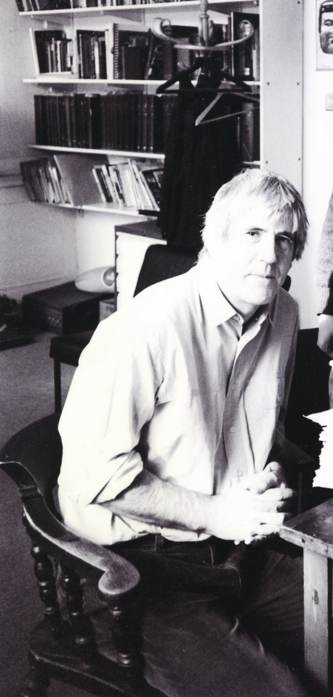

Paul Foot, an investigative journalist, editor and left-wing campaigner, worked variously for the *Daily Record*, the *Daily Mirror*, the *Guardian* and *Private Eye*. He was involved in many high-profile campaigns throughout his illustrious career, including the Birmingham Six, the Bridgewater Four and the John Poulson scandal. His accolades include the Journalist of the Year, the Campaigning Journalist of the Year, the George Orwell Prize for Journalism and in 2000 he was honoured as the Campaigning Journalist of the Decade. Paul Foot died in 2004 at the age of 66.

**For further information please contact Digby Halsby on 020 7590 8909**

**or email** [**Digby.Halsby@midaspr.co.uk**](mailto:Digby.Halsby@midaspr.co.uk)